The Hisgrove Family

Joseph Hisgrove
Born 1836
Left Bristol, UK on the 1st August 1853 on the barque ‘Cotfield’ arriving into Port Adelaide on the 1st December 1853.
Died 25th May 1917 South Australia.
Married Margaret Hisgrove (born Kelly) on 14th Jan 1857 at the dwelling place of John Fisher, at Truro, South Australia.
Their first child, Sarah Jane was born on 30th January 1958 in Truro. The couple had 18 children (including 2 sets of twins), some of the children were un registered. Of the 18, 9 died young. The last child, John Farina was born on 16th December 1879.
Over the years the family lived at the Prince Alfred Mine, then to Sliding Rock Mine, then Mt Lyndhurst and then onto Farina.
After Farina was surveyed at proclaimed a town in 1878, Joseph Bought lot 429 in 1878 where he was listed as a Teamster and then in 1879 he bought lots 29, 366, 383,430. He also was working a Butcher (as noted in the Land Title for Lot 29 - CT306/122).

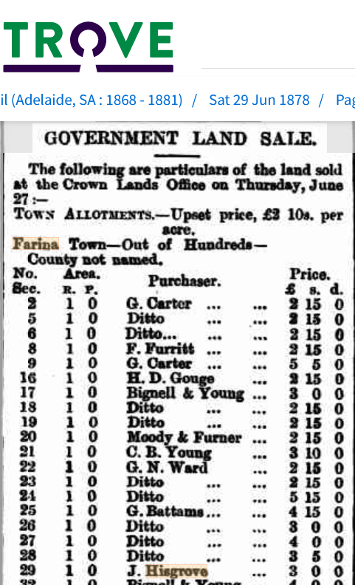

Joseph latter sold Lot 430 (CT_297_245) to in son in law Charles Adam. Charles was the head stockman at Cordillo Downs. In May 1889, Joseph his daughter Charlotte and Charles Adam all travelled to Birdsville. It is thought that Charlotte and Charles intended to be married in Birdsville. However, they could not to do so as the town is in Queensland and they did not meet the required ‘residency’ period to be married there.
Charlotte and Charles Adams were married on 5th July 1889 in Innamincka. They remained at Cordillo Downs Station until 1897.
For the birth of there first 2 children, Charlotte travelled from Cordillo Downs to Farina. Both trips she described at ‘terrible journeys’. For the first hundred miles it was necessary to go by buggy to Innamincka, then by Passenger/Mail coach to Farina.
Joseph established a Butchering business in Farina. He later sold his butchering business and bought 3 teams of bullocks to take stores and equipment to outlaying stations. These round trips would take from six weeks to 6 months.
He was granted the Slaughtering License between 1881-1884.
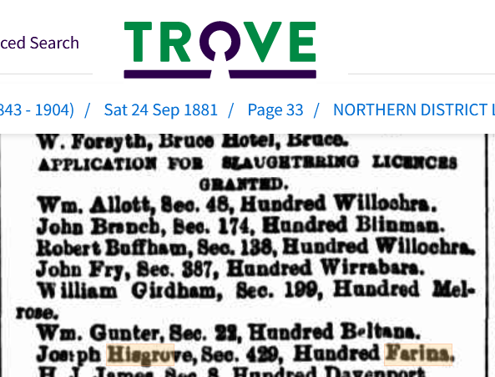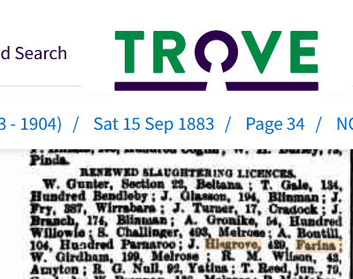

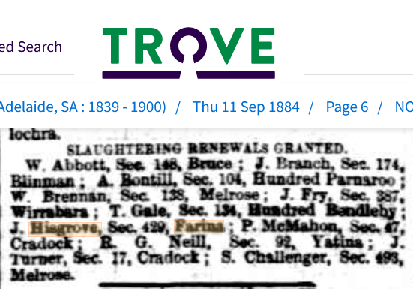

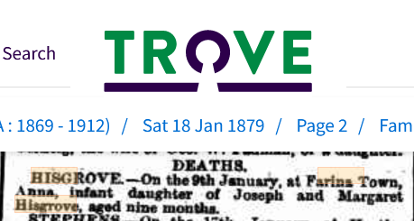
Anna (Born 25th March 1878) is buried in the Farina Cemetery.
Joseph and Margaret’s last child John Farina Hisgrove was born in 16th December 1879 and died 9 December 1880 and is also buried in the Farina Cemetery.
Interesting reading, listing names of people from Farina in 1887 including Mrs Margaret Hisgrove. Anne Craig is buried in the Farina cemetery as well as your husband.
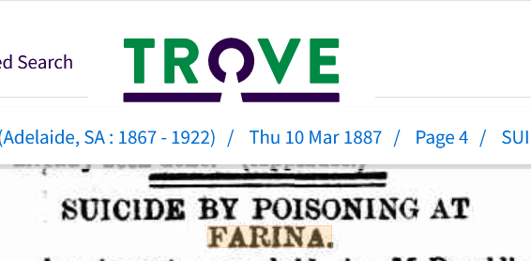
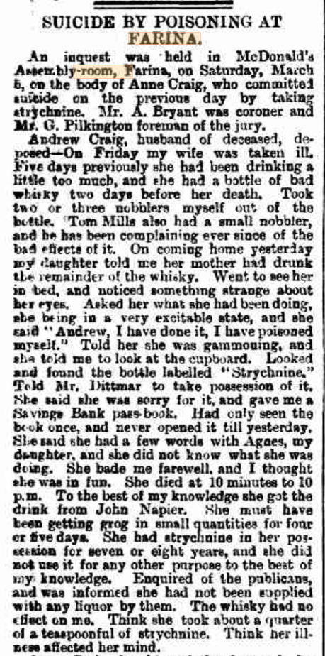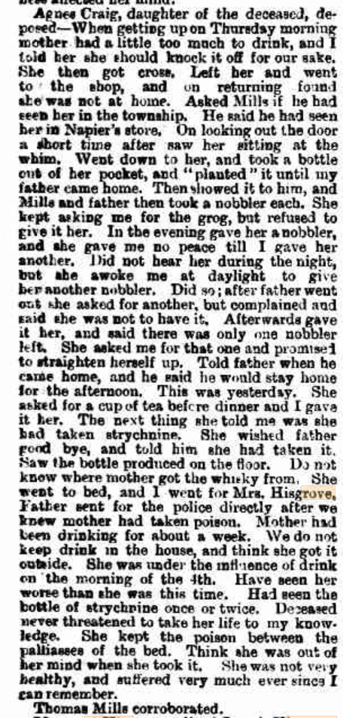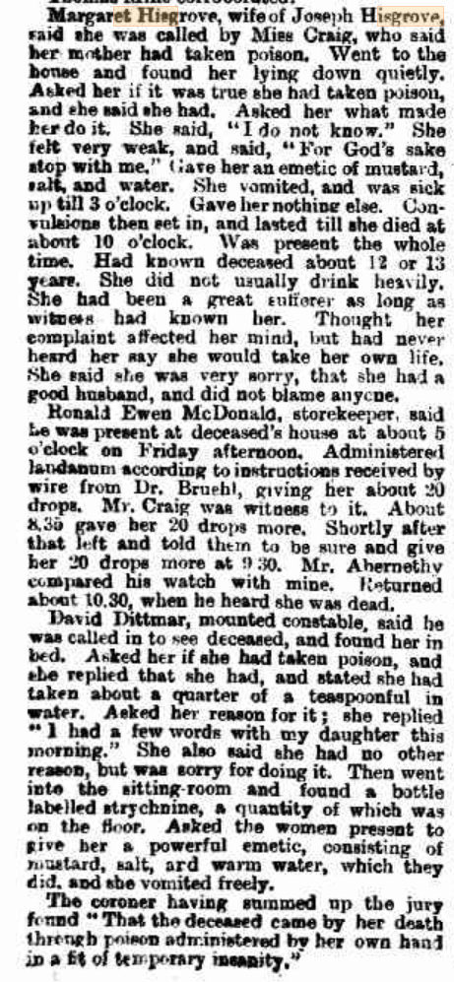
In 1892 Joseph dismantled the below house in Farina (lot 429) and transferred it via bullock wagons and rebuilt it at Beltana.
Joseph transferred the land to Elizabeth, but she never returned to Farina to live, as the town was declining.
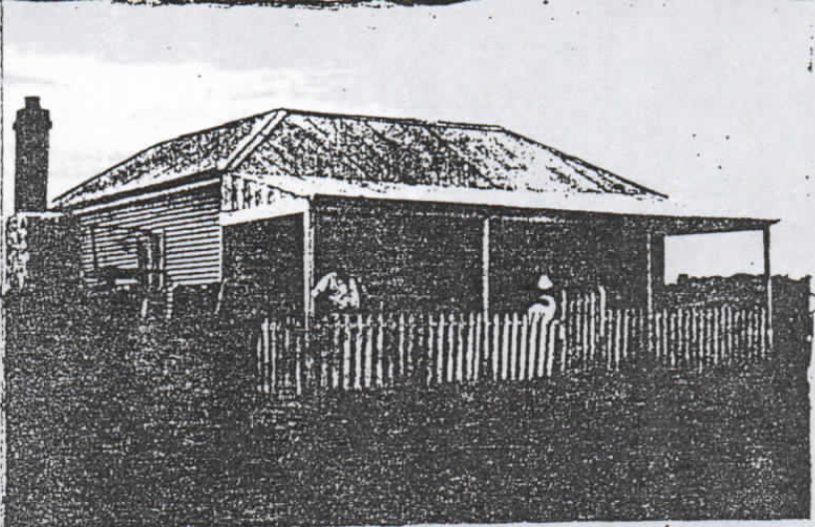

Mary Ann Pedlar was the eldest daughter of Sarah Jane Pedlar and eldest grand daughter of Joseph and Margaret Hisgrove, married William Arthur Dawes on 11 August 1892 in Broken Hill when he was 28 years old. They had eight children in 12 years.
William Arthur Dawes’s profile can be read on the Farina website :
https://farinarestoration.com/history/people-of-farina/william-arthur-dawes/

The rest of the Hisgrove Family History can be viewed by the research conducted by Mrs Elizabeth Madge Stuart (from Western Australia). She unfortunately passed away in 2008.

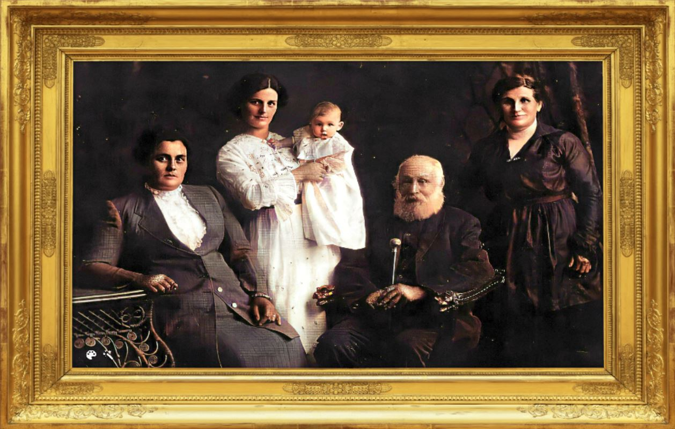
Mary Ann Dawes Sarah Jane Pedlar Linda Dawes Joseph Hisgrove Margaret Hisgrove
(nee Pedlar) (nee Hisgrove)

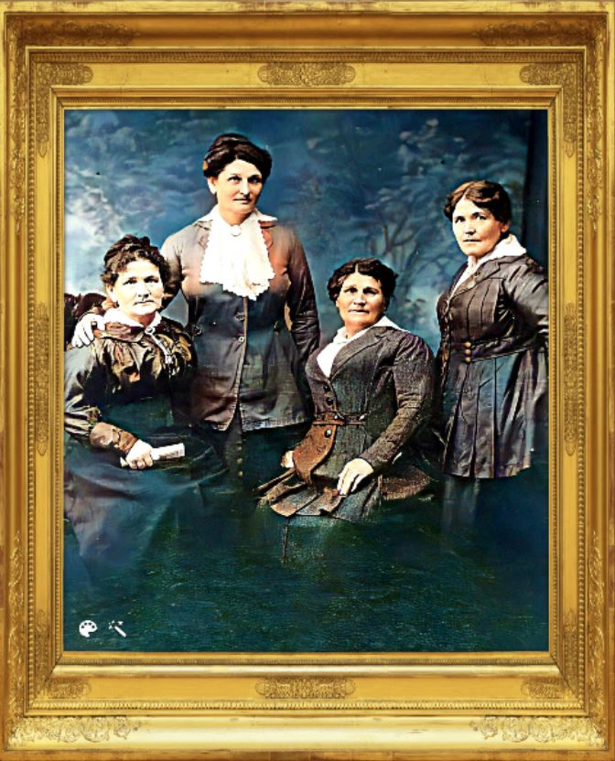
Some of the Hisgrove Sisters
Elizabeth Ellen Mary Ann Sarah
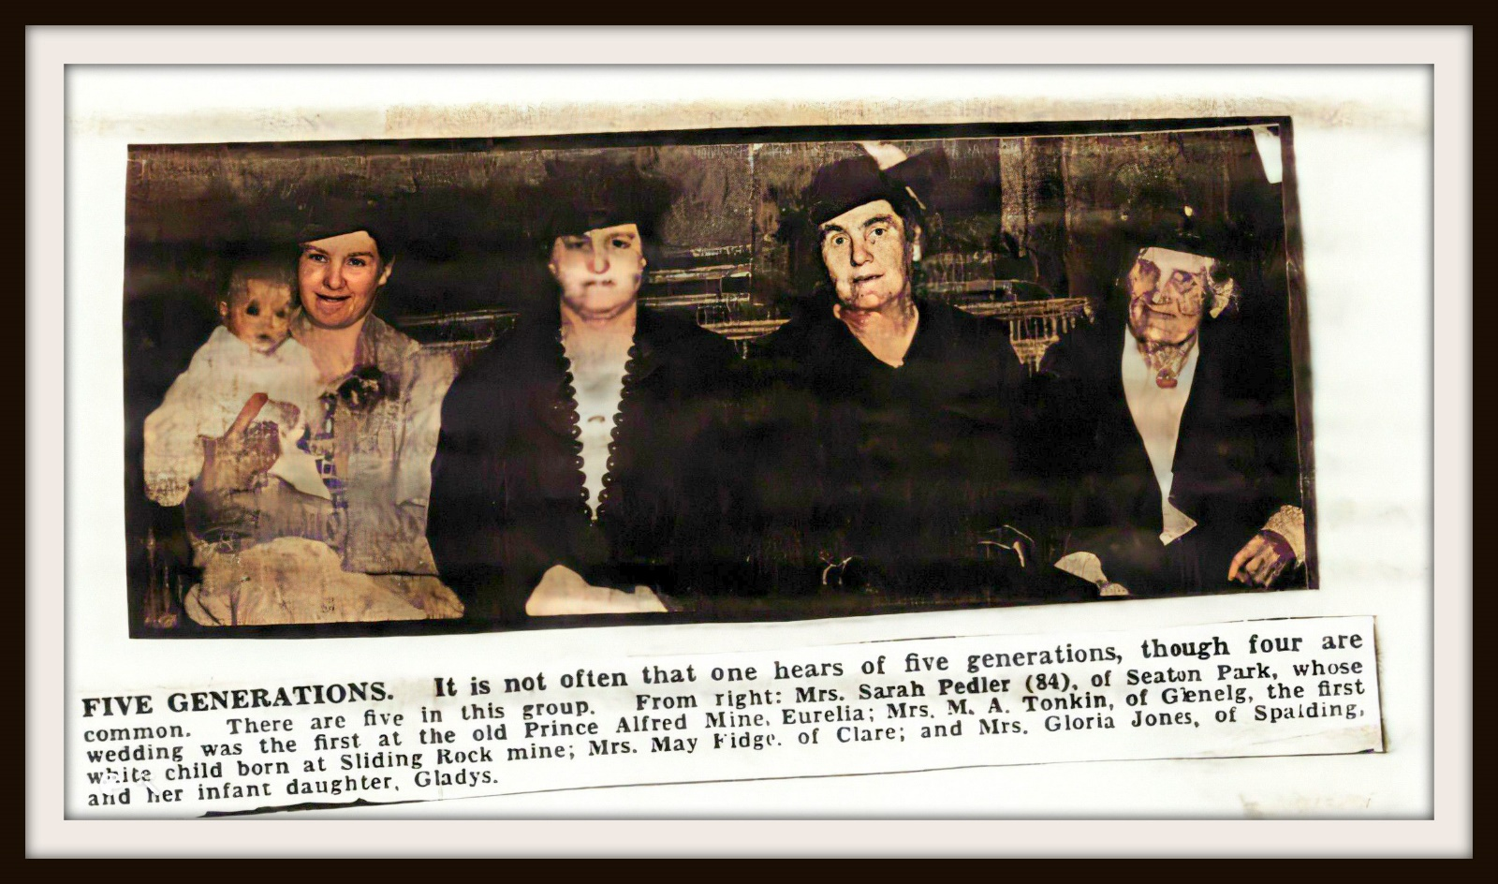Five Generations

